Chapter 5: Methodology and Implementation

5.1 Overview
Chapter 5 describes the implementation methodology of the Agentic RAG Tutor system. Part A covers the complete RAG pipeline — document ingestion, chunking, embedding, vector storage, knowledge graph (KG) construction, hybrid retrieval, agentic reasoning, and the frontend/backend implementation. Part B covers the Quiz Generation, Knowledge Distillation, and Fine-Tuning pipeline.

5.2 Part A – Agentic RAG Tutor Implementation

5.2.1 Document Ingestion Pipeline
5.2.1.1 Supported Formats and Parsing Strategy
The ingestion pipeline supports five document formats, each handled by a dedicated parser: PDF (PyMuPDF/fitz, with OCR fallback for scanned pages); DOCX (python-docx XML traversal for paragraphs, tables, and headings); PPTX (python-pptx slide iteration with slide-number tagging); TXT (UTF-8 read, passed directly to cleaning); and CSV (pandas row linearisation into natural-language sentences before chunking).
5.2.1.2 OCR Pipeline
When native PDF text extraction yields no content, pages are rendered at 300 DPI via PyMuPDF's pixmap renderer and passed to Tesseract OCR after the following pre-processing steps: grayscale conversion, adaptive thresholding, deskew correction, noise reduction, image sharpening, and binarisation.
5.2.1.3 Text Cleaning and Normalisation
Extracted text is normalised before chunking. Cleaning steps include: header/footer removal via page-frequency analysis; hyphenation correction (end-of-line hyphens rejoined); Unicode NFC normalisation with non-printable character removal; whitespace collapse; and noise filtering of page numbers, empty figure captions, and punctuation artefacts.

5.2.2 Chunking Strategy and Metadata
5.2.2.1 Chunking Method Selection
The system uses semantic chunking (SemanticChunker) to group sentences by embedding similarity, preserving coherent meaning units. For KG construction, kg_chunking_strategy.py applies zero-overlap chunking (maximum 8 chunks per document; documents under 30 sentences treated as a single chunk). Table 5.1 lists the shared hyperparameters.
Table 5.1: Chunking Hyperparameters
Parameter | RAG Chunking | KG Chunking | Rationale
Similarity threshold | 0.82 | 0.82 | Sentence grouping boundary
Max sentences/chunk | 25 | 25 | Upper bound before forced split
Overlap sentences | Configured per deployment | 0 | KG: zero overlap prevents duplicate entity extraction
Min / Max tokens | 25 / 2000 | 25 / 2000 | Discard short chunks; fit within LLM context window
Single-chunk threshold | — | 30 sentences | Short docs kept intact for KG
Max chunks/doc | — | 8 | Limits KG extraction LLM calls
5.2.2.2 Metadata Association per Chunk
Each chunk is stored in PostgreSQL (content.document_chunks) with: document_id (UUID FK), user_id, chunk index, page_start, page_end, raw text, and an embedding vector (pgvector column). At the document level, each chunk is also tagged with source filename, section heading, semantic tags, and extracted entities.

5.2.4 Embedding Generation
Text chunks are embedded in batches during ingestion and stored in the pgvector column. Re-ingestion uses MD5 content hashing to skip unchanged documents. Table 5.2 compares the evaluated models; the final system uses intfloat/e5-base-v2 (768-dimensional embeddings) for its superior retrieval performance.
Table 5.2: Embedding Model Comparison
Model | Dim. | Speed | Quality | Selection Rationale
all-MiniLM-L6-v2 | 384 | Very Fast | Moderate | Lightweight baseline
bge-base-en-v1.5 | 768 | Fast | High | Strong semantic retrieval
intfloat/e5-base-v2 | 768 | Fast | Very High | Best retrieval performance on evaluation benchmarks (selected)

5.2.5 Vector Database Integration
Embeddings are stored in PostgreSQL (pgvector extension) in the content.document_chunks table, indexed with an HNSW index using cosine distance. Metadata filters (user_id, subject_id, document_ids) are applied as SQL WHERE conditions.

5.2.6 Knowledge Graph Construction
5.2.6.1 Entity and Relationship Extraction
KG triples are extracted from document chunks using an LLM-based pipeline (kg_extractor.py). The EXTRACTION_PROMPT instructs the model to: detect the document's academic domain from a fixed taxonomy; extract named entities normalised to Title Case; extract directional semantic relationships using domain-specific vocabularies; and prohibit generic relations (RELATES_TO, HAS, IS, WAS). For multi-chunk documents, up to 1,500 characters of the preceding chunk tail are prepended to support cross-chunk entity linking.
5.2.6.2 Graph Schema and Node/Edge Types
Three primary structural node types are defined: User, Subject, and Document (connected via HAS_SUBJECT and HAS_DOCUMENT edges). Entity nodes store name, type, document_id, subject_id, and user_id; uniqueness is enforced by the composite MERGE key (name, document_id, user_id). Cross-document edges are annotated with cross_doc: true.
5.2.6.3 Graph Database Integration
Neo4j stores entities, relationships, and cross-document concept connections. All writes use idempotent Cypher MERGE operations, and node/edge creation is batched with Cypher UNWIND, reducing round trips from O(N) per entity to O(1) per batch. The POST /chunk endpoint (chunk_kg.py) orchestrates the full KG construction workflow: it retrieves existing PostgreSQL chunks for a document UUID, performs per-chunk LLM extraction with checkpoint-based recovery, persists the graph to Neo4j, and executes a cross-subject merge pass on completion.
5.2.6.4 KG Maintenance and Update Strategy
On re-ingestion with a changed content hash, delete_document_graph removes the existing graph before rebuilding, and cross-subject edges are regenerated afterward. For subjects with more than 10 documents, cross-document comparisons are restricted to consecutive document pairs, reducing complexity from O(N²) to O(N).

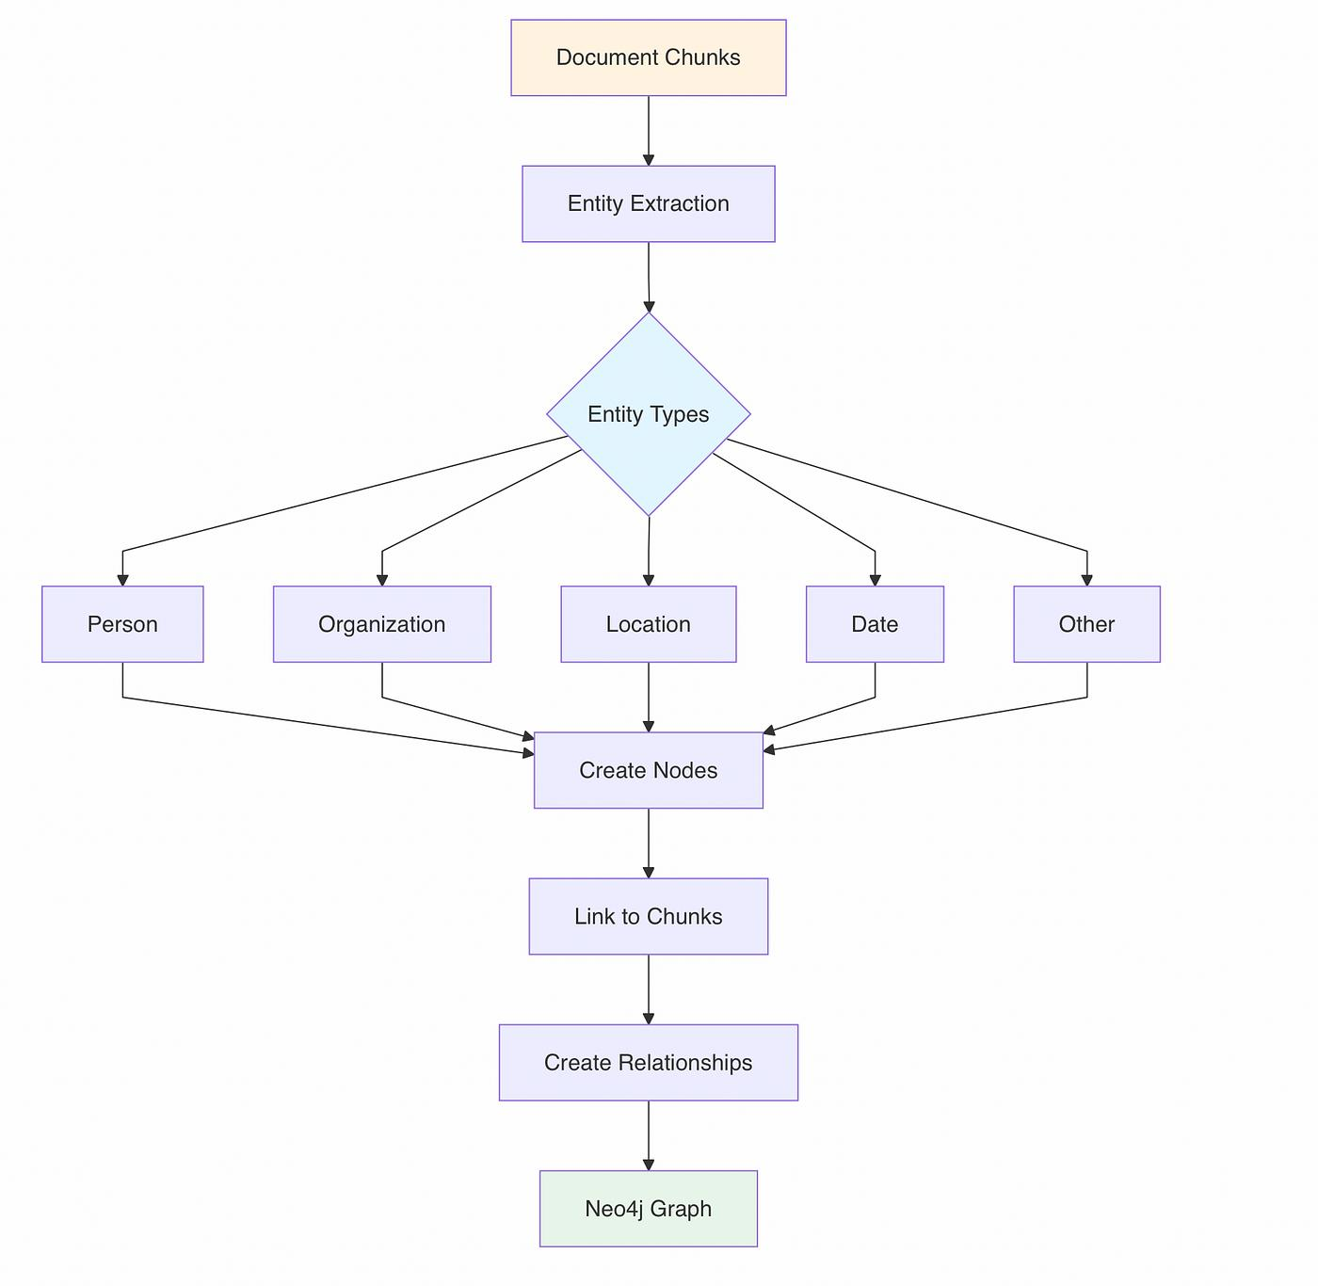
Figure 5.1: Knowledge Graph Construction Workflow

5.2.7 Hybrid Retrieval System
5.2.7.1 Vector (Dense) Retrieval
User queries are embedded using intfloat/e5-base-v2. A pgvector cosine similarity search retrieves the top-k most semantically relevant chunks (default k = 10), filtered by subject_id and optionally by document_ids.
5.2.7.2 Keyword (BM25/Sparse) Retrieval
Sparse retrieval uses PostgreSQL Full-Text Search with BM25-style ranking. Chunks are indexed as tsvector representations at ingestion time; queries are transformed into tsquery expressions at runtime. This channel is particularly effective for exact terminology, abbreviations, acronyms, equations, technical symbols, and low-frequency proper nouns.
5.2.7.3 Knowledge Graph Retrieval and Traversal
KG retrieval (kg_service.py: retrieve_subgraph_for_subject) identifies query entities via LLM-based NER or a rule-based fallback. Seed entities are matched with flexible substring matching, then a hop-bounded subgraph traversal (default: 2 hops) is executed in Neo4j, returning entity nodes, semantic relationship edges, and multi-hop triples.
5.2.7.4 Score Fusion Strategy
Dense, sparse, and KG retrieval results are combined using Reciprocal Rank Fusion (RRF):
RRF(d) = Σ 1 / (k + rᵢ(d))
where rᵢ(d) is the rank of chunk d in retrieval system i and k = 60. The fused ranked list proceeds to cross-encoder re-ranking.

5.2.8 Query Expansion
LLM-based query expansion generates semantically related variations (synonyms, rephrasing, sub-query decomposition, and optional HyDE). Expanded query embeddings are retrieved separately and merged during the fusion stage.

5.2.9 Prerequisite Reasoning and Concept Linking
Prerequisite concepts are identified by traversing prerequisite relationships in the knowledge graph and integrated into the final context to improve explanation quality.

5.2.10 Multi-Hop Retrieval
Multi-hop retrieval operates at two levels: (1) KG subgraph traversal depth controls evidence collection across connected entities; (2) IRCoT-style iterative retrieval interleaves retrieval steps with intermediate chain-of-thought reasoning, appending partial reasoning to the query for subsequent passes.

5.2.11 Cross-Encoder Re-Ranking
After RRF fusion, the top candidate chunks are re-ranked by a cross-encoder that jointly encodes the query and each candidate to compute precise relevance scores. This step is applied only to the top-k candidates due to its computational cost.

5.2.12 Context Selection and Compression
The final context is assembled from the re-ranked output by selecting the most relevant and diverse chunks based on relevance score, evidence diversity, and token budget. Redundant or highly overlapping chunks are removed, and the context is compressed to fit the model's token limit. Web search is also available as an augmentation channel: when local retrieval confidence is low or current information is required, web results are filtered, merged with local evidence, and annotated with explicit citations.

5.2.14 Hallucination Detection and Confidence Scoring
5.2.14.1 Hallucination Detection Method
The generated response is decomposed into atomic claims C = {c₁, c₂, ..., cₙ}. Each claim is verified against retrieved evidence using semantic similarity and NLI-based comparison: S(cᵢ, E) ∈ {0, 1}. A response is flagged as hallucinated when (Σ S(cᵢ, E)) / n < τ.
5.2.14.2 Confidence Score Computation
Confidence = w₁·R + w₂·K + w₃·G + w₄·E (Σwᵢ = 1)
where R = dense retrieval score, K = sparse retrieval score, G = KG support score, and E = evidence grounding score = (supported claims) / (total claims).
5.2.14.3 Response Filtering and Fallback Strategy
If confidence falls below threshold θ, the system triggers a fallback: expanded vector search, additional KG traversal, or web augmentation. If confidence remains insufficient, the system returns a simplified explanation based only on verified evidence or requests user clarification.

5.2.16 Citation Generation
Post-generation, passage-level attribution references the source document filename, chunk index, and page range. Citations are formatted inline and optionally as a numbered reference list.

5.2.17 Adaptive Tutoring Actions
The system supports four adaptive tutoring actions. (1) Explanation Generation: the LLM is conditioned on retrieved context, student interaction history, and target difficulty level; prompts incorporate analogies, step-by-step reasoning, and simplified interpretations, with depth adapted dynamically to difficulty setting or inferred performance. (2) Hint Generation: hints are issued in increasing specificity — early hints offer conceptual direction; later hints add detail without disclosing the final answer; depth is controlled by hint-request count or prior incorrect attempts. (3) Quiz Recommendation: KG traversal identifies concept dependencies while student mastery scores prioritise lower-mastery concepts for reinforcement. (4) Study Plan Update: per-concept mastery scores are updated after every interaction using quiz accuracy, hint usage, and response correctness; difficulty triggers prerequisite reinforcement, and mastery unlocks advanced topics.

5.2.18 Audio Query Processing
Speech-to-text transcription uses OpenAI Whisper. Audio pre-processing covers noise reduction, silence trimming, normalisation, and format/duration validation. Transcribed text enters the same retrieval and reasoning pipeline as text queries; transcriptions are returned to the client for verification before submission.

5.2.19 Backend API Implementation (ASP.NET Core)
5.2.19.1 Architecture Overview
The backend is an ASP.NET Core (.NET 8) Web API following a clean, layered architecture. It serves as the integration hub between the Flutter mobile client, PostgreSQL, and the Python AI microservice; all endpoints are secured with JWT Bearer authentication. Table 5.3 summarises the technology stack.
Table 5.3: Technology Stack — Backend
Layer / Concern | Technology | Role
Runtime | ASP.NET Core (.NET 8) | Web API host
Database | PostgreSQL + pgvector | Relational storage + vector embeddings
ORM | Entity Framework Core (Npgsql) | Database access and migrations
Background Jobs | Hangfire (PostgreSQL storage) | Async document processing pipeline
Authentication | JWT Bearer Tokens | Stateless user authentication
Validation | FluentValidation + AutoValidation | Request DTO validation before action execution
AI Service | Python FastAPI (via HTTP) | RAG, KG, Quiz, Audio microservice
API Documentation | Swagger / OpenAPI with XML comments | Developer-facing endpoint documentation
5.2.19.2 Key Endpoints
Table 5.4: Key API Endpoints
Group | Method | Route | Purpose
Document | POST | /api/Document | Upload document (max 10 MB)
 | PUT | /api/Document | Update metadata (title, subject)
 | DELETE | /api/Document/{id} | Delete document + file + KG data
 | GET | /api/Document | List all user documents
 | GET | /api/Document/{id}/download | Download physical file
 | POST | /api/Document/{id}/retry-processing | Re-queue failed document
Chunks | GET | /api/DocumentChunk/{documentId} | Get all RAG chunks for a document
Chat Session | POST | /api/ChatSession | Create session scoped to documents
 | GET | /api/ChatSession | List all sessions
 | PUT / DELETE | /api/ChatSession / /{id} | Update title / delete session
Chat Message | POST | /api/ChatMessage/SendMessage | RAG answer from uploaded documents
 | POST | /api/ChatMessage/SearchWeb | Answer from live web search
 | GET | /api/ChatMessage/{sessionId} | Get messages with citations
 | POST | /api/ChatMessage/STT | Speech-to-Text transcription
 | POST | /api/ChatMessage/{id}/TTS | Text-to-Speech synthesis
Subject | POST / GET | /api/Subject | Create / list subjects
 | PUT / DELETE | /api/Subject/{id} | Rename / delete subject + cascade
Auth | POST | /api/Auth/register | Register → returns JWT
 | POST | /api/Auth/login | Authenticate → returns JWT
 | POST | /api/Auth/forgot-password | Request reset token (anti-enumeration)
 | POST | /api/Auth/reset-password | Reset password with valid token
User | GET / PUT / DELETE | /api/User/profile | Get / update / delete user profile
5.2.19.3 Middleware Pipeline
Table 5.5: Middleware Pipeline
Order | Middleware | Purpose
1 | UseCors | Allow any origin, method, header
2 | UseHangfireDashboard | Job monitoring dashboard (protected)
3 | UseSwagger / UseSwaggerUI | OpenAPI docs at /swagger
4 | UseHttpsRedirection | Redirect HTTP → HTTPS
5 | UseStaticFiles | Serve uploads from wwwroot/uploads
6 | UseAuthentication | Validate JWT Bearer tokens
7 | UseAuthorization | Enforce [Authorize]; reject with 401
8 | FluentValidation AutoValidation | Return 400 before action if DTO invalid
9 | MapControllers | Route requests to controller actions
5.2.19.4 Dependency Injection
All services follow the Interface → Implementation pattern and are registered in Program.cs with Scoped lifetime (one instance per HTTP request). Table 5.6 lists service registrations; named HttpClient instances (IHttpClientFactory) are configured with per-client timeouts as shown in Table 5.7.
Table 5.6: Service Registrations
Interface | Implementation | Purpose
IUserRepository / IUserService | UserRepository / UserService | User data access and profile CRUD
IAuthService | AuthService | Registration, login, password reset
IEmailService | SmtpEmailService | Password reset emails (Transient)
IPasswordHasher | BCryptPasswordHasher | BCrypt password hashing
ISubjectRepository / ISubjectService | SubjectRepository / SubjectService | Subject CRUD and business logic
IDocumentRepository / IDocumentService | DocumentRepository / DocumentService | Document CRUD, validation, hash-check, retry
IFileStorageService | LocalFileStorageService | Save / delete physical files in wwwroot
IDocumentChunkRepository / IDocumentChunkService | DocumentChunkRepository / DocumentChunkService | RAG chunk access; calls Python AI for chunking
IChatSessionRepository / IChatSessionService | ChatSessionRepository / ChatSessionService | Chat session data access and CRUD
IChatMessageRepository / IChatMessageService | ChatMessageRepository / ChatMessageService | Message access; RAG, web search, STT, TTS
IChatWebSourceRepository | ChatWebSourceRepository | Web search citation storage
DocumentChunkingJob | — | Hangfire background job: chunking + KG build (Transient)
IBackgroundJobClient | Hangfire built-in | Enqueue and chain background jobs
Table 5.7: Named HttpClient Instances
Client | Timeout | Purpose
ChatMessageService | 10 min | RAG chat, web search, STT, TTS
DocumentChunkService | 10 min | Document and quiz chunking
DocumentService / SubjectService | 100s | KG delete on document / subject deletion
5.2.19.5 Design Patterns
Table 5.8: Applied Design Patterns
Pattern | Where Applied
Repository Pattern | Every data-access layer — services never write SQL directly
Service Layer Pattern | Every business-logic layer — controllers contain no business logic
Dependency Injection (IoC) | All layers — constructor injection; no static service locators
Strategy Pattern | Password hashing — IPasswordHasher; algorithm is swappable
Options Pattern | JWT config — IOptions<JWT> bound from appsettings.json
Factory Pattern | HTTP clients — IHttpClientFactory with per-client timeouts
Generic Result Wrapper | Service responses — ServiceResponse<T>; no exceptions to controllers
Background Job / Job Chaining | Document processing — Hangfire Enqueue + ContinueJobWith for KG build
DTO / Anti-Corruption Layer | API contracts and AI integration — DTOs isolate EF Core and Python data shapes
5.2.19.6 Error Handling
Controller actions follow a guard-clause pattern: authentication check → FluentValidation AutoValidation → business-rule preconditions → service call. Services use ServiceResponse<T> to avoid propagating exceptions to controllers; failure conditions return descriptive messages (validation errors, ownership checks, AI communication failures, and non-2xx AI responses). Background jobs set ProcessingStatus = FAILED and QuizChunkingStatus = FAILED on failure, re-throw for Hangfire's retry policy, and expose a retry route (POST /api/Document/{id}/retry-processing). Input validation is summarised in Table 5.9.
Table 5.9: Input Validation Techniques
Technique | Scope and Detail
FluentValidation | Auth DTOs: minimum password complexity, valid email format, and required fields.
AutoValidation | Intercepts model binding on every request; invalid DTOs return 400 before action executes.
Manual file validation | Max 10 MB; allowed extensions: .pdf, .docx, .txt, .pptx; content-type and extension both checked.
Duplicate detection | MD5 hash of file content computed at upload; duplicate rejected before storage or processing.
Audio validation | STT endpoint validates MIME type and file size before forwarding to Python AI.
5.2.19.7 Integration with the Python AI Microservice
All AI functionality is delegated to a Python FastAPI microservice; endpoint paths are centralised in appsettings.json. Document processing is fully asynchronous, executing three sequential Hangfire stages after upload: (1) RAG chunking (POST /extract/embed) — segments the document, generates pgvector embeddings, and bulk-inserts into content.document_chunks; (2) Quiz chunking (POST /quiz/process) — produces enriched chunks in a separate quiz_chunks table; (3) KG construction (POST /chunk/) — runs LLM-based entity/relationship extraction and writes the graph to Neo4j.
RAG Chat: POST /api/ChatMessage/SendMessage validates session ownership, saves the user message, then calls POST /chat/ with the message text and AllowedDocumentIds; the response includes the answer, confidence score, chunk citations, and KG context. Web Search: messages are routed to POST /web-search; the response includes the generated answer and a Sources array (URL, domain, title) saved as ChatWebSource entities. Audio integration details are given in Table 5.10. On document or subject deletion, the corresponding KG graph is purged via DELETE /kg/document/{id} or DELETE /kg/subject/{id} before the database record is removed; KG cleanup failure is caught silently. Table 5.11 lists all Python AI endpoints.
Table 5.10: Audio Integration
Feature | Python Endpoint | Implementation Detail
Speech-to-Text | POST /audio/stt | Audio streamed as multipart/form-data; transcribed text returned to client.
Text-to-Speech | POST /audio/tts | AI returns raw audio bytes; .NET saves locally and stores URL; repeated requests use the cached file.
Table 5.11: Python AI Endpoint Reference
Python Endpoint | Purpose
POST /extract/embed | Extract text + generate pgvector embeddings
POST /quiz/process | Generate enriched quiz chunks
POST /chunk/ | Build Knowledge Graph in Neo4j
POST /chat/ | RAG-based question answering with KG context
POST /web-search | Live web search Q&A with source citations
POST /audio/stt | Speech-to-Text transcription
POST /audio/tts | Text-to-Speech synthesis
DELETE /kg/document/{id} | Purge Neo4j graph on document deletion
DELETE /kg/subject/{id} | Purge Neo4j graph on subject deletion

5.2.20 Frontend Implementation
5.2.20.1 Flutter Mobile Application – Key Features and Screens
[Describe the Flutter mobile app screens: chat interface, document upload, quiz screen, study plan view. Mention state management approach and key packages used.]
Figure 5.3: UI Wireframes / Screenshots – Chatbot Interface — [Insert screenshot or wireframe]
5.2.20.2 Web Application – Key Features and Pages
[Describe the web application pages, framework used, and key interactive features. Include the document upload interface and how it communicates with the backend API.]
Figure 5.4: UI Wireframes / Screenshots – Document Upload Interface — [Insert screenshot or wireframe]

